TITLE: DETERMINATION OF THE ACID-DISSOCIATION CONSTANT


Aims and Objectives:
- To determine the acid dissociation constant of the indicator, phenol red using the Spectrophotometer method.
- To learn how to use the pH-meter to determine the pH of a solution.
- To learn how to use the spectrophotometer to measure the absorbance of a given solution.

INTRODUCTION
An acid-base indicator is a weak organic acid or base added to a solution to indicate by colour change the point at which equivalent amounts of the acid has reacted with equivalent amount of the base. Acid base indicators can exist in either an acid or base form. The two forms have different colours. Thus the indicator turns one colour in an acid and turns another colour in a base. Knowledge of the pH at which the indicator turns from one form to the other can help one to tell whether a solution has a lower or higher pH (i.e. acidic or basic).

HOW AN ACID-BASE INDICATOR WORKS
An acid-base indicator can also be defined as weak organic acid or base that contains a highly delocalised planar pi-bonding system. In a sufficiently acidic solution the indicator is protonated (say Hln).In a sufficiently basic solution the indicator is converted to its conjugate base (say ln⁻).
The deprotonation of Hln changes the structure of the indicator, which alters the pattern of electron delocalisation in the pi system. This change in the indicator’s delocalised pi system also causes a change in its colour.
Hln + H₂OH₃O⁺ + ln⁻
(Colour x) (Colour y)

The concentration of an indicator is negligible compared to the concentration of the solution to which it is added. Indicators are also usually present as minor species in the solution .Therefore the colour change is often determined by the dominant equilibrium. Hence in a sufficiently acidic solution, the equilibrium will shift to the left, producing colour ‘x’, whiles in a sufficiently basic solution the equilibrium shifts to the right to give colour ‘y’.
Indicators are weak acids or bases, therefore they dissociate partially in aqueous solution.
From the equation above the acid dissociation constant, Ka is given by

Ka = [H⁺][ln⁻]
[Hln]
Rearranging and taking logs gives:
pH = pka + log [ln-]
[Hln]

As the two forms the indicator has different colours, with the help of the spectrophotometer, absorbance measurement can be used to determine the pka of the indicator from the equation
pH = pka + log (A-A_{Hln)}
(A_{ln}-A)

Where “A’’ is the absorbance at a wavelength of 550nm
A_{Hln} is the minimum absorbance
A_{ln} is the maximum absorbance

APPARATUS AND CHEMICALS

0.067moldm⁻³ KH2PO4 0.025 moldm⁻³ NaB4O3 .10H2O
0.067moldm⁻³ NaHPO4 0.025 moldm⁻³ NaHCO3
0.1 moldm⁻³ HCl 0.025 moldm⁻³ Na₂CO3
Spectrophotometer
pH meter

PROCEDURE
- The required amounts of each of the solutions provided were measured into a beaker to prepare the buffer solution.
- Exactly 1cm³ of phenol red was added to 25cm³ of each of the buffers prepared and their pH was measured (using the pH meter) and recorded.
- Later with the help of the spectrophotometer, the absorbance of each of the solutions in the range 350 to 680nm was measured and recorded.
- Also the absorbance of each of the solutions was measured at a wavelength of 550nm.
- Using A_{Hln} as the minimum absorbance and A_{ln} as the maximum absorbance value the quantity log [(A-AHln)/ (Aln-A)] was calculated.
- A graph of pH against log [(A-AHln)/ (Aln-A)] was plotted and y-intercept was determined.
- log [(A-AHln)/(Aln-A)]

TABLE OF VALUES

pH | Buffer /cm³ | 440λ | 470λ | 490λ | 520λ | 550λ | 570λ | 590λ | 680λ
6.0 | KH₂PO₄/Na₂HOP₄ | 0.08 | 0.0 | 0.05 | 0.11 | 0.03 | 0.01 | 0.00 | -0.01
6.4 | KH₂PO₄/Na₂HOP₄ | -0.09 | -0.07 | -0.06 | -0.06 | -0.06 | -0.04 | -0.08 | -0.08
6.8 | KH₂PO₄/Na₂HOP₄ | -0.07 | -0.07 | -0.07 | -0.06 | -0.03 | -0.04 | -0.07 | -0.08
7.2 | KH₂PO₄/Na₂HOP₄ | 0.11 | -0.17 | 0.29 | 0.30 | 0.39 | 0.33 | 0.34 | 0.28
7.6 | KH₂PO₄/Na₂HOP₄ | 0.20 | 0.18 | 0.14 | 0.21 | 0.29 | 0.19 | 0.18 | 0.19
8.0 | KH₂PO₄/Na₂HOP₄ | 0.24 | 0.32 | 0.37 | 0.28 | 0.24 | 0.22 | 0.32 | 0.39
8.4 | HCl/Borax/DIH₂O | 0.02 | 0.07 | 0.11 | 0.11 | 0.15 | 0.17 | 0.07 | 0.06
8.8 | HCl/Borax/DIH₂O | 0.10 | 0.11 | 0.15 | 0.18 | 0.21 | 0.19 | 0.10 | 0.07
9.0 | HCl/Borax/DIH₂O | 0.13 | 0.13 | 0.16 | 0.20 | 0.25 | 0.21 | 0.12 | 0.09
10.0 | HCl/Borax/DIH₂O | 0.08 | 0.08 | 0.10 | 0.13 | 0.21 | 0.14 | 0.07 | 0.03

pH | Wavelength (λ) | Absorbance A | A- A_{Hln} | A_{ln} -A | log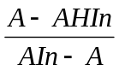
6.0 | 550 | 0.03 | 0.03 | 0.08 | -0.426
6.4 | 550 | -0.06 | -0.02 | -0.03 | -0.176
6.8 | 550 | -0.03 | 0.01 | -0.05
7.2 | 550 | 0.39 | 0.56 | -0.05
7.6 | 550 | 0.29 | 0.15 | -0.09
8.0 | 550 | 0.24 | 0.02 | 0.15 | -0.875
8.4 | 550 | 0.15 | 0.13 | 0.02 | 0.813
8.8 | 550 | 0.21 | 0.14 | -0.02
9.0 | 550 | 0.25 | 0.16 | -0.04
10.0 | 550 | 0.21 | 0.18 | -0.07

From the equation pH = pKa + log y= mx+c

Using the method of least squares in which
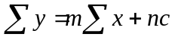............. (1)
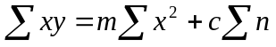………. (11)
The gradient m is calculated from
m=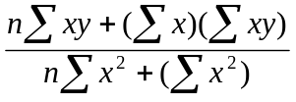……….. (I)
and the intercept, c=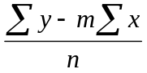……… (11)
where n= number of terms

x=log | y=pH
-0.426 | 6.0
-0.176 | 6.4
 | 6.8
 | 7.2
 | 7.6
-0.875 | 8.0
0.813 | 8.4
 | 8.8
 | 9.0
 | 10.0

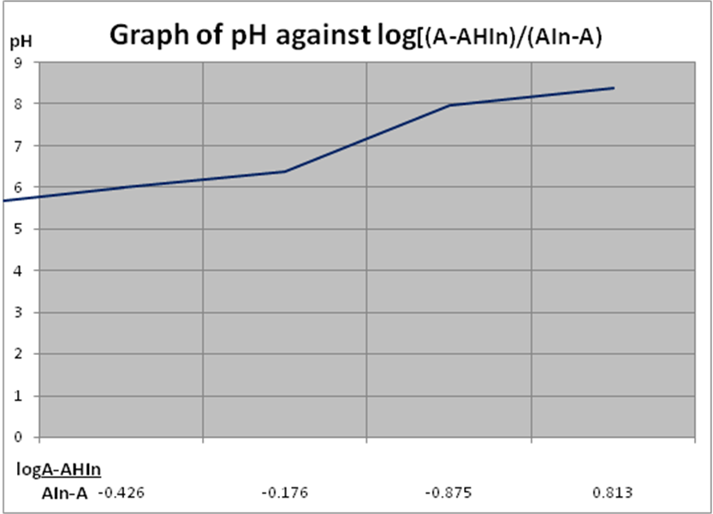

From the graph, the equation of the graph is y=1.937x + 5.80
Therefore the slope of the graph is 1.937.
The pKa = the y- intercept = 5.80

The Ka = 10 ^{-5.80}= 1.58 x 10⁻⁶

DISCUSSION
From the result gathered from the experiment, it can be seen that, the absorbance of the buffers increased with increasing pH. Therefore, it can be concluded that the absorbance of a given solution is directly proportional to its pH.
Again, in acidic medium, a buffer solution with pH below 7, the colour of the unionized form of the phenol red is dominant. As the intensity increases, the yellow colour also intensifies as the corresponding pH moves to the acidic medium. This indicates that phenol red changes to yellow in the acidic medium.

Whilst, in the basic medium, the pink colour, that is the basic form of the phenol red becomes dominant. The pink intensified with an increase in pH. The purple colour obtained at higher pH when pink intensifies.
Also it was observed that the colour of the indicator (phenol red) in a sufficiently acidic solution (i.e. pH > 7) was yellow. This colour changed to red and to deep red as the pH of the buffers increased above 7.The pKa of phenol red determined from the graph is 5.80.This value deviated from the true value (i.e. 7.9) appreciably.
The isobestic point is that point at which the absorbance is equal for all three points.

ERROR ANALYSIS
- The concentrations of the solutions prepared may be less, or greater than the assumed values.
- The spectrophotometer may give wrong readings which can affect the results.
- The pKa value obtained experimentally from the true value due to a defect in the spectrometer thus not recording accurate values.

PRECAUTIONS
- It was ensured that the spectrophotometer reading was at zero before any measurement was taken.
- It was ensured that the glass wares were thoroughly washed before and after use.
- It was ensured that the solutions prepared were not spilled on the tables.

CONCLUSION
The literature pKa value is 7.9 and the experimental value from the calculations is 5.80.The Ka value is 1.58 x 10⁻⁶.
The absorbance of a solution is directly proportional to its pH.The colour of phenol red indicator is yellow in a sufficiently acidic solution and red in a sufficiently basic solution.
The pKa of phenol red indicator can be determined graphically and by calculation.
The working range of phenol red is within the range 4.8-8.0

REFFERENCES
Chemistry the central science 7th edition by Brown Lemay Bursten (Page 597-8)
Chemistry the molecular science by Olmsted and Williams (803-5).

NAME: SENYO DENNIS A. AKANDE

COURSE: BSC. CHEMICAL ENGINEERING

YEAR: FIRST YEAR

EXPERIMENT NO. : P.1.2.2.

I.D. NO: 1314507

T.A.: ATTA ALHASSAN
DATE: 19TH MARCH, 2008.

PRE-LAB

Temperature (ºC) | Volume C₂O₄²⁻ (mL) | Volume MnO₄⁻ 1.05 (mL)
20 | 5.00 | 1.05
40 | 5.00 | 1.26
60 | 5.00 | 1.65
80 | 5.00 | 2.00

Temp (ºC) InK | T (Kelvin) | 1/T (Kelvin⁻¹) | [Oxalate] | K | Ink
20 | 293 | 3.413 x 10⁻³ | 4.952 x 10⁻⁵ | 2.452 x 10⁻⁹ | -19.826
40 | 313 | 3.195 x 10⁻³ | 4.128 x 10⁻⁵ | 1.704 x 10⁻⁹ | -20.190
60 | 333 | 3.003 x 10⁻³ | 3.152 x 10⁻⁵ | 9.766 x 10⁻¹⁰ | -20.747
80 | 353 | 2.833 x 10⁻³ | 2.6 x 10⁻⁵ | 6.76 x 10⁻¹⁰ | -21.115

- C=n/v C=n/v
n(MnO₄⁻) = 1.04 x 10⁻⁴ n(MnO₄⁻) = 2 = 9.905 x 10⁻⁵ C(C₂O₄²⁻) = 2.476 x 10⁻⁴
1.05 n(C₂O₄²⁻) 5 x 5.00
= 9.905 x 10⁻⁵ x = 2.476 x 10⁻⁴ = 4.952 x 10⁻⁵

- n(MnO₄⁻) = 1.04 x 10⁻⁴ n(MnO₄⁻) = 2 = 8.254 x 10⁻⁵ C(C₂O₄²⁻) = 2.064 x 10⁻⁴
1.26 n(C₂O₄²⁻) 5 x 5.00
= 8.254 x 10⁻⁵ x = 2.064 x 10⁻⁴ = 4.128 x 10⁻⁵

- n(MnO₄⁻) = 1.04 x 10⁻⁴ n(MnO₄⁻) = 2 = 6.303 x 10⁻⁵ C(C₂O₄²⁻) = 1.576 x 10⁻⁴
1.65 n(C₂O₄²⁻) 5 x 5.00
= 6.303 x 10⁻⁵ x = 1.576 x 10⁻⁴ = 3.152 x 10⁻⁵

- n(MnO₄⁻) = 1.04 x 10⁻⁴ n(MnO₄⁻) = 2 = 5.2 x 10⁻⁵ C(C₂O₄²⁻) = 1.3 x 10⁻⁴
2.00 n(C₂O₄²⁻) 5 x 5.00
= 5.2 x 10⁻⁵ x = 1.3 x 10⁻⁴ = 2.6 x 10⁻⁵

K = [OX⁻²] ²
= (4.952 x 10⁻⁵)²
= 2.452 x 10⁻⁹

= (4.128 x 10⁻⁵)²
= 1.704 x 10⁻⁹

= (3.125 x 10⁻⁵)²
= 9.766 x 10⁻¹⁰

= (2.6 x 10⁻⁵)²
= 6.76 x 10⁻¹⁰

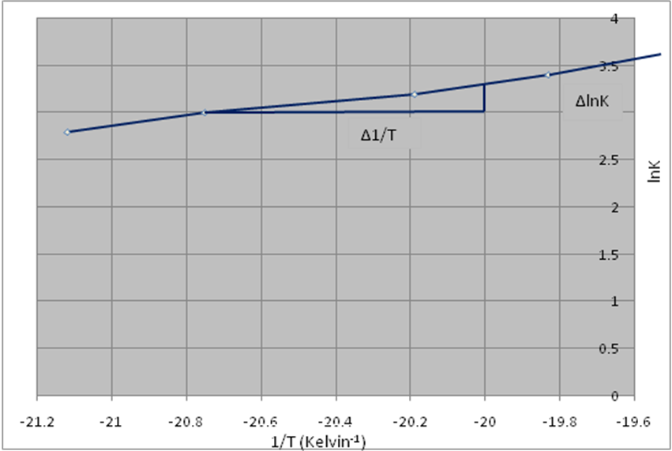

lnK = (∆Hº/R)(1/T) + (∆Sº/R)

From the graph:
lnK = y
∆Hº/R = ∆lnK = y₂ – y₁
∆H 1/T x₂ – x₁

= -21.115 + 19.826
2.83 x 10⁻³ – 3.41 x 10⁻³

= 2222.41

∆Hº = 2222.41 = 2222.41
R 8.314
= 267.31 J

1/T = x

Y – intercept (∆Sº/R) = 3.6

∆Sº = 3.6
R
= 3.6
8.314
= 0.43

